
CSE387 - Data Mining
Phase 1
Team 7

3/24/2026
Presented to Eng. Esraa Karam


Presented by:
Ahmed Mohamed Naguib - 23P0305
Ahmed Mohamed Fahmy - 23P0303
Loay Khaled Mohammed - 23p0340
Kareem Ahmed Talat - 23P0225
Omar Tarek Mosaad - 23P0278

Table of Contents
1.0 Introduction 1
2.0 Dataset Understanding 2
3.0 Preprocessing 2
4.0 Outlier Detection 2
5.0 Data Assessment and Correlation Analysis 2
6.0 Encoding 2
7.0 Conclusion 2

1.0 Introduction

The objective of this phase is to analyze the given dataset and prepare it for machine learning models to perform accurate predictions based on the given features. This involves understanding the structure of the data, identifying potential issues, and applying appropriate preprocessing techniques. The dataset consists of a categorical mushroom dataset containing 8,124 observations and 23 feature dimensions, with the goal of building a foundation for robust classification models.

Key Phase 1 Activities:
- Data Exploration: Load and inspect the raw dataset to understand structure, feature types, and target distribution.
- Preprocessing: Handle missing values, remove duplicates, and validate data integrity.
- Outlier Detection: Identify and flag rare categorical patterns using frequency based statistical thresholds.
- Association Analysis: Quantify relationships between features and the target using categorical association measures.
- Encoding Preparation: Create a leakage-safe, encoding-ready representation of the dataset.

2.0 Dataset Understanding
The dataset includes 8,124 mushroom samples, each described by 23 categorical attributes representing physical characteristics of mushrooms. All variables in the dataset are categorical. No continuous numerical variables are present, which require categorical preprocessing techniques before machine learning models can be applied.
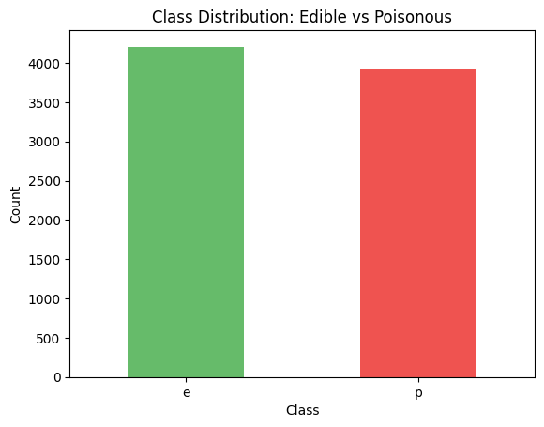
The target variable class indicates whether a mushroom is e (edible) or p (poisonous):
Class | Count
Edible (e) | 4208
Poisonous (p) | 3916

2.1 Feature Space
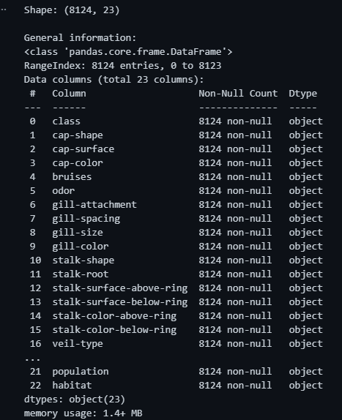
The dataset contains 23 categorical predictor variables describing mushroom morphology and habitat conditions. These features represent observable characteristics such as cap shape, gill structure, stalk properties, and habitat environment.
Examples of feature groups include:
- Cap features: shape, surface, color
- Gill features: attachment, spacing, size, color
- Stalk features: root type, surface texture, color
- Other characteristics: veil type, ring type, spore print color, habitat
Each category is encoded using short symbolic values (e.g., n = brown, y = yellow, w = white).

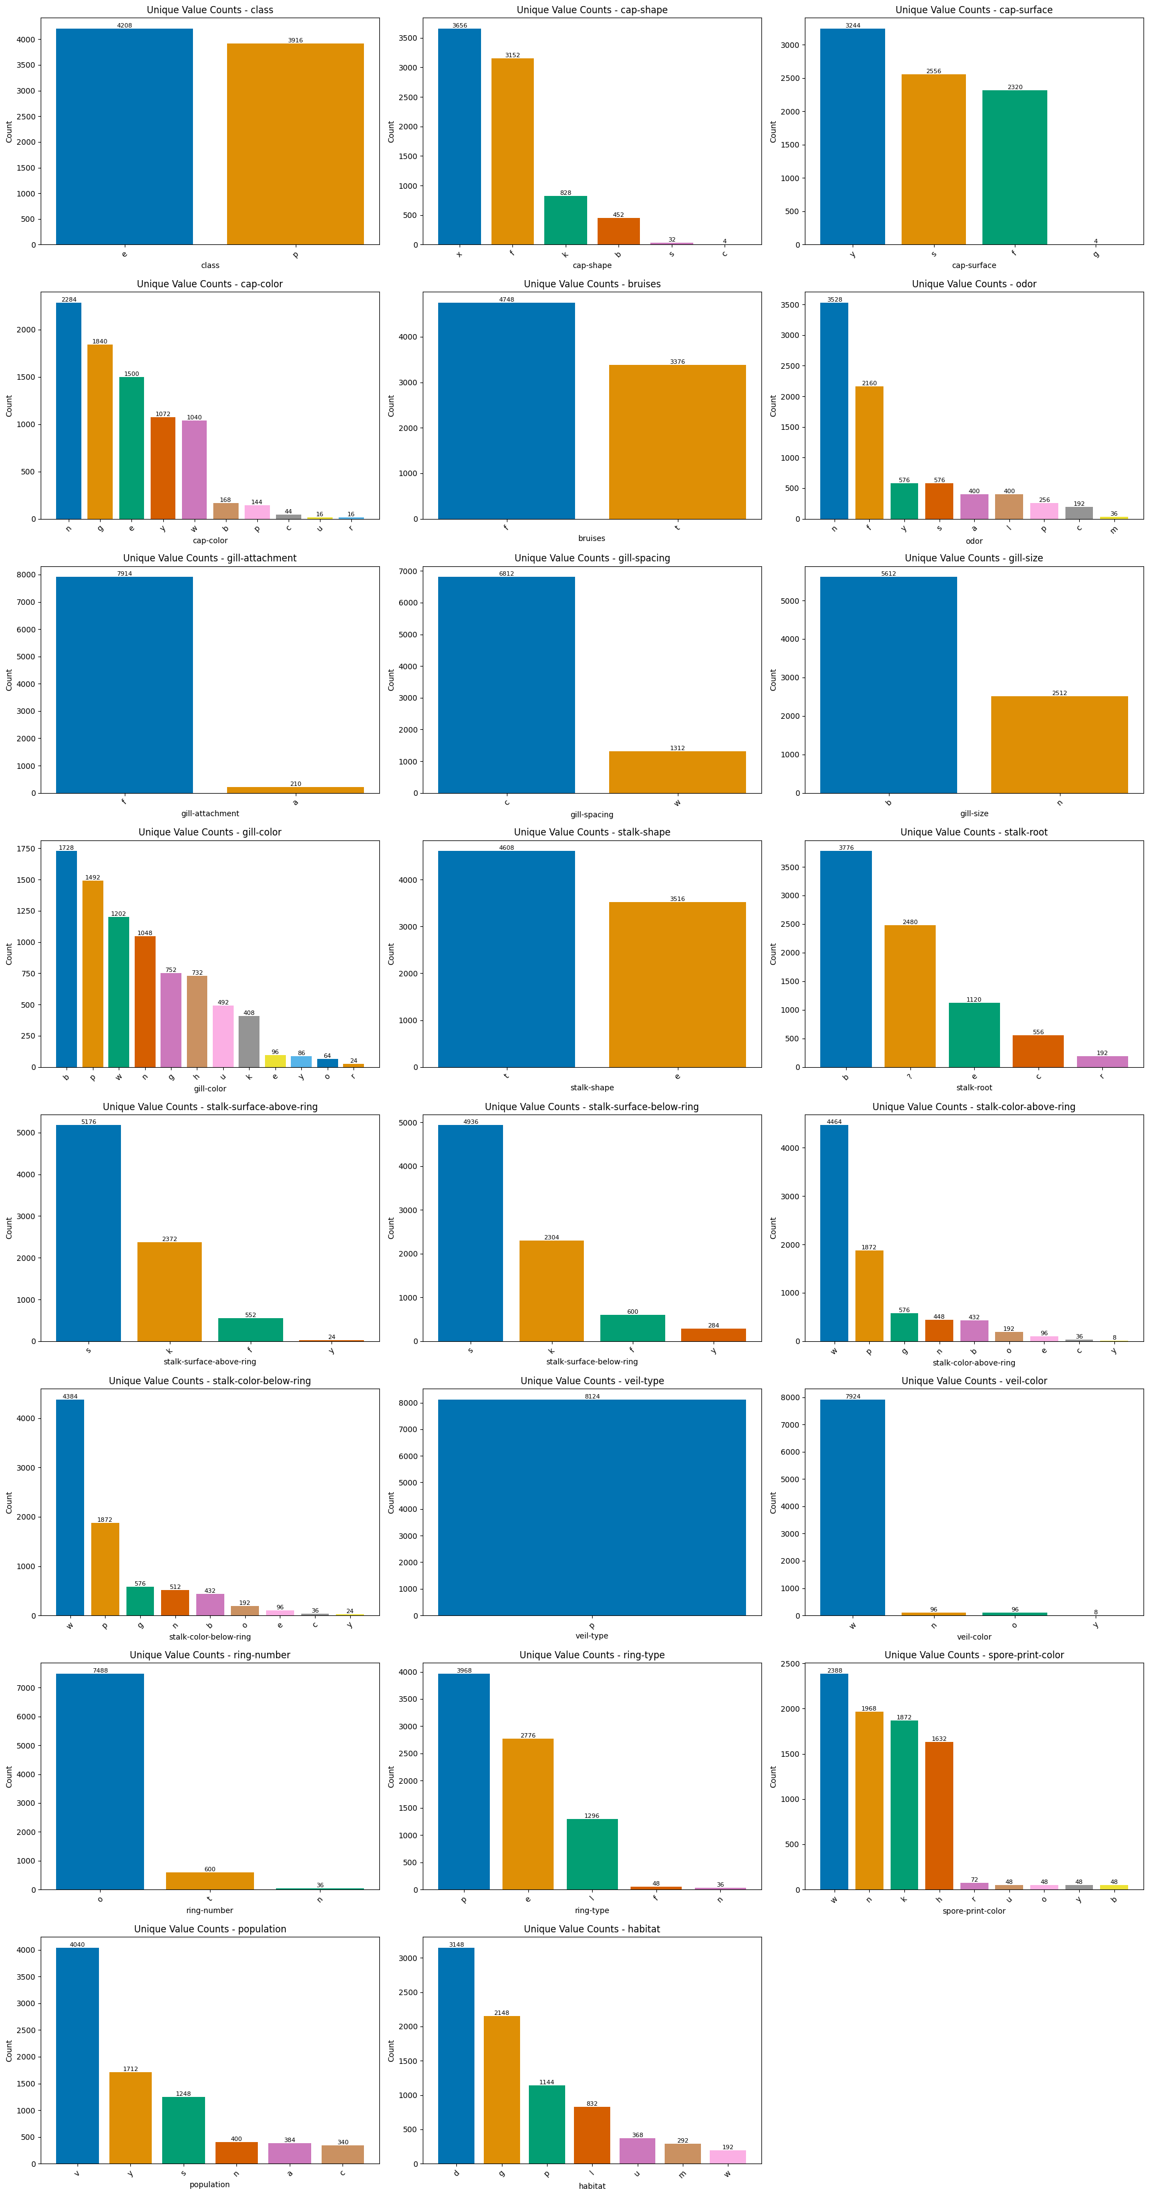

3.0 Preprocessing
Data preprocessing ensures the dataset is clean and suitable for analysis. Since the mushroom dataset consists entirely of categorical variables, preprocessing focuses on data quality rather than numerical transformations. The main preprocessing steps include:
- Handling missing values
- Removing redundant features
- Checking for duplicate records
These steps ensure consistency and reliability before further statistical analysis.
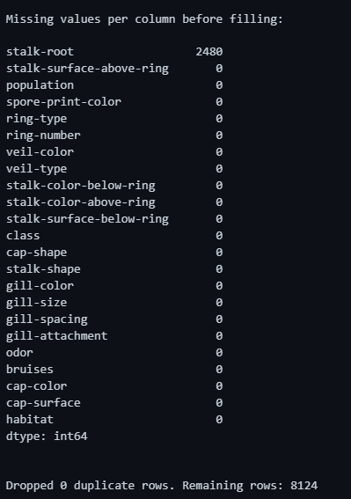
3.1 Missing Value
Missing values in the dataset are encoded using the symbol “?”. Initial inspection shows that missing values are concentrated in the stalk-root feature, while all other features contain complete observations.
Since all variables are categorical, missing values are replaced using mode imputation (the most frequent category). This method preserves the natural distribution of categories within each feature. For the stalk-root feature, the most frequent category was b, which was used to replace the missing values.
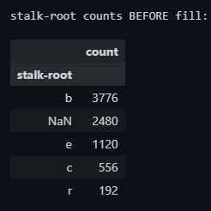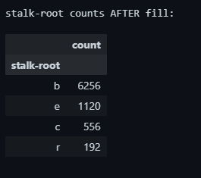
3.3 Feature Simplification
During inspection, the feature veil-type was found to contain only a single category across all observations. Features with a single constant value do not contribute useful information for analysis or machine learning models. Therefore, this feature was removed from the dataset.
3.4 Duplicate Records
Duplicate observations were checked and removed to avoid redundant information. The inspection revealed no duplicate rows, indicating that all records represent unique observations.


4.0 Outlier Detection
Traditional outlier detection methods such as z-score or IQR are designed for numerical data and rely on distance or magnitude comparisons. Since the mushroom dataset contains only categorical variables, outliers are instead defined as observations containing rare category values.
Rare categories represent values that occur very infrequently in the dataset and may indicate unusual biological variants, data recording errors, or observations from uncommon environmental conditions.
4.1 Frequency Based Detection
Rare Category Threshold
Outliers are identified using frequency thresholding. A category is considered rare if its frequency is less than 1% of the dataset size. This threshold captures categories that appear extremely infrequently while keeping common patterns intact.
Detection Procedure
For each feature (excluding the target variable):
- Compute the frequency of all category values
- Identify categories occurring below the threshold
- Mark rows containing at least one rare category as outliers
The final outlier set consists of the union of all rows containing rare categories across any feature.
Rare Category Detection Results
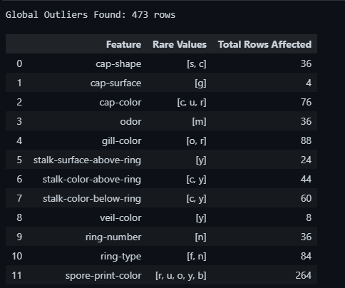
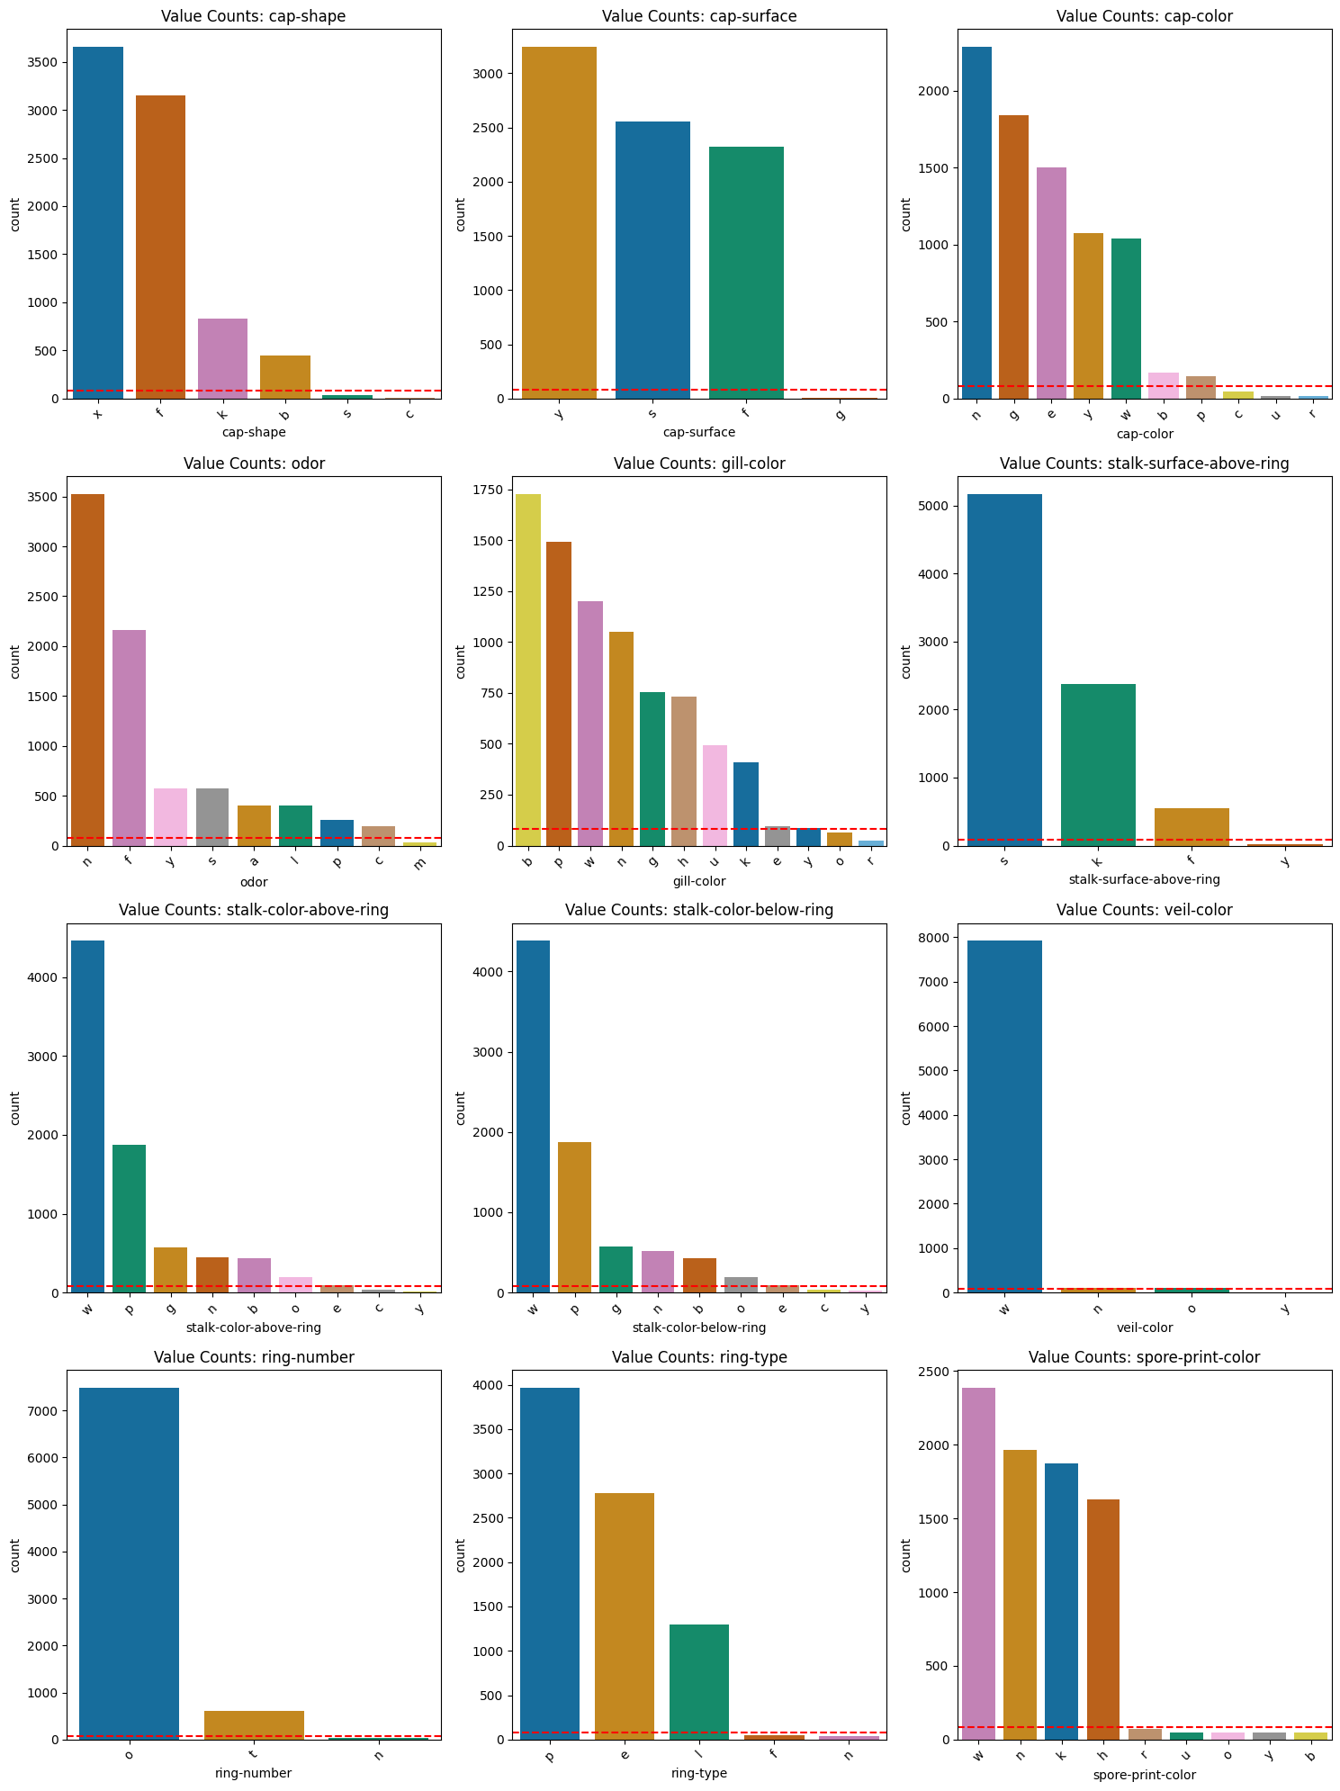

4.2 Outlier Summary
The overall results of the outlier detection process are summarized below.
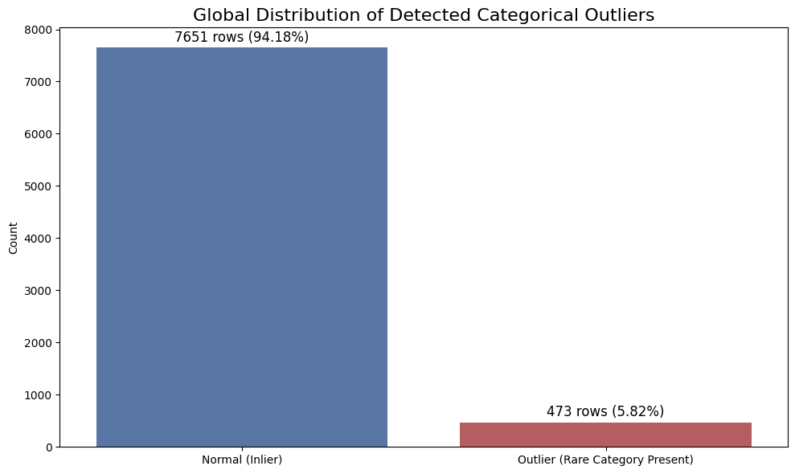
Rows containing rare categories were flagged as outliers and excluded from subsequent statistical analysis. Removing these observations reduces noise and prevents extremely sparse categories from distorting feature association measurements.

5.0 Data Assessment and Correlation Analysis
After completing data preprocessing and removing outliers, the next step is to analyze the relationships between categorical features. Understanding these relationships is critical for identifying dependencies, reducing redundancy, and determining which features contribute most to predicting the target variable (class).
The correlation analysis was performed on the cleaned dataset after removing all rows flagged as outliers.
- Total Rows: 7,651
- Total Features: 22 (excluding the outlier flag)
This ensures that the computed associations are not distorted by rare or noisy categories identified in the previous step.
5.1 Cramér’s V Symmetric Association Analysis
Cramér’s V is based on the Chi-Square statistic and measures the strength of association between two categorical variables. It produces values between 0 and 1 where 0 implies No Association and 1 implies Perfect Association
A full pairwise matrix was computed for all feature combinations using contingency tables.
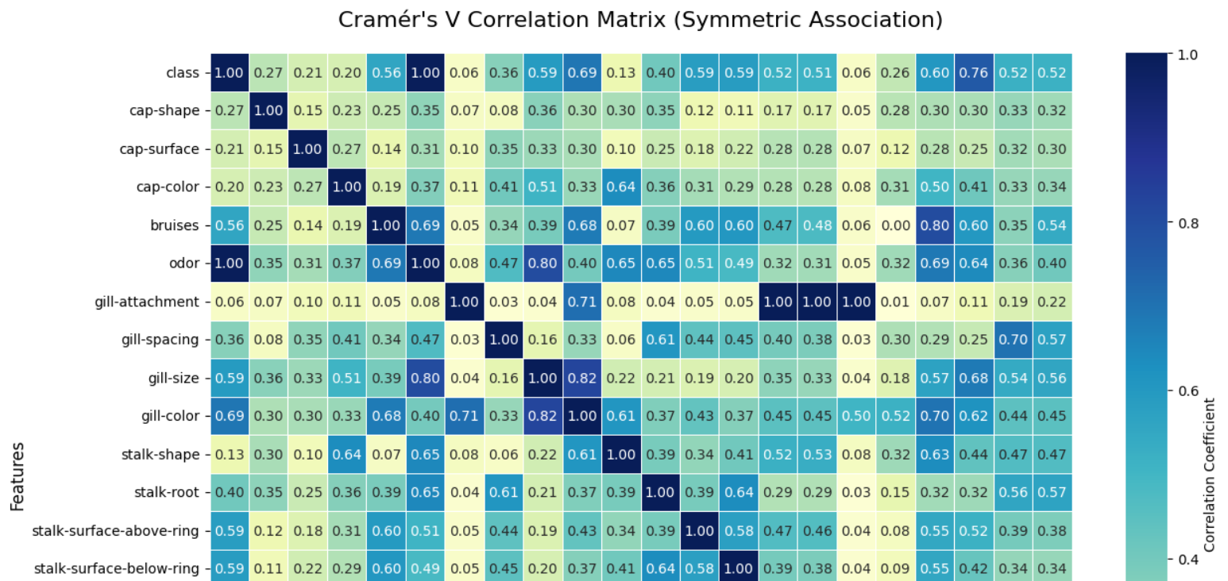
Key Findings
The strongest feature associations identified were:
- gill-attachment ↔ veil-color → 1.000
- gill-attachment ↔ stalk-color-above-ring → 1.000
- gill-attachment ↔ stalk-color-below-ring → 1.000
- class ↔ odor → 0.995
- gill-size ↔ gill-color → 0.822
- odor ↔ gill-size → 0.805
- bruises ↔ ring-type → 0.803
Several important insights can be derived:
- Perfect Correlations (V = 1.0)
Features such as gill-attachment, veil-color, and stalk-color are perfectly correlated. This suggests redundancy, meaning one feature may be removed without losing information.
- Strong Relationship with Target Variable
Odor has an extremely strong association with class (0.995), indicating it is a critical predictor.
- Clustered Feature Groups
Features like gill-size, gill-color, and odor form tightly connected groups, suggesting underlying structural relationships.
5.2 Theil’s U Asymmetric Information Gain
Theil’s U measures how much knowing one variable reduces uncertainty about another. This is particularly useful for identifying predictive features for the target variable.

U(X → Y) ≠ U(Y → X)

Values range from 0 to 1 where 0 implies no predictive power and 1 implies perfect prediction
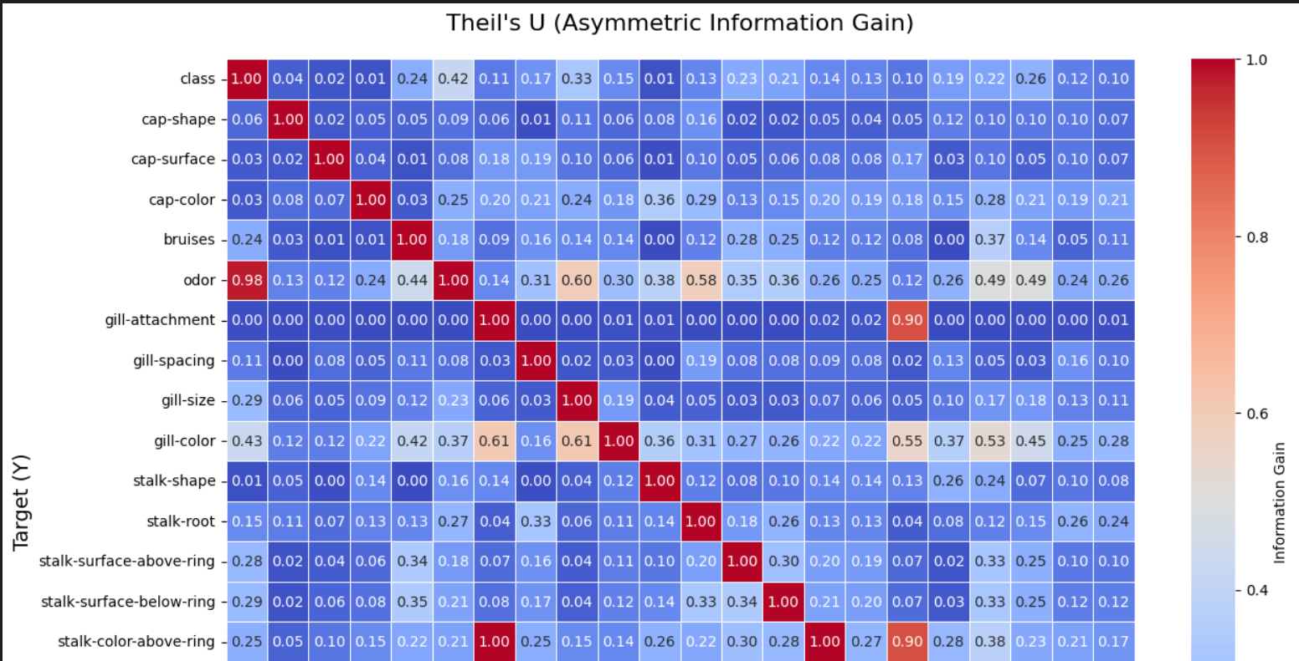
Predictive Insights (Information Gain > 50%)
The following features provide strong predictive power:
- odor → class → 97.81%
- ring-type → bruises → 56.23%
- stalk-color-above-ring → gill-attachment → 100%
- population → gill-spacing → 50.43%
- gill-color → gill-size → 61.08%
- spore-print-color → ring-type → 54.27%
Interpretation
- Dominant Predictor: Odor
Odor alone explains ~98% of the uncertainty in mushroom toxicity making it the most influential feature in the dataset.
- Deterministic Relationships
Some features (e.g., stalk-color-above-ring → gill-attachment) show 100% information gain, indicating direct dependency.
- Moderate Predictors
Features such as spore-print-color and population provide moderate predictive value and may enhance model performance when combined.

5.3 Target-Specific Feature Importance
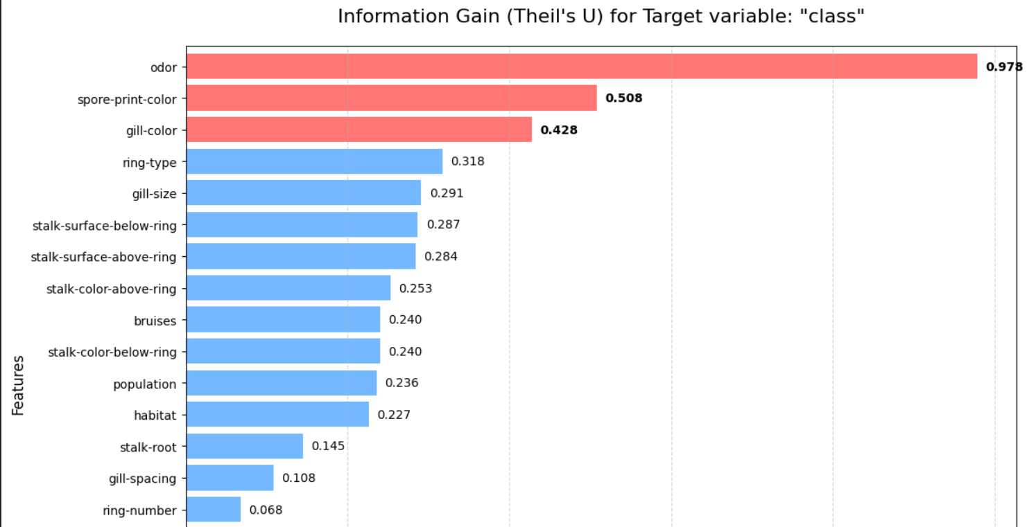
To better understand prediction of the target variable (class), features were ranked using Theil’s U.
Top Informative Features for Mushroom Toxicity:
- Odor → 97.81%
- Spore-print-color → 50.78%
- Gill-color → 42.76%
- Ring-type → 31.78%
- Gill-size → 29.13%
From the correlation and information gain analysis:
- The dataset contains highly correlated feature groups, indicating redundancy.
- Odor is the single most important predictor of mushroom toxicity.
- Several features exhibit deterministic or near-deterministic relationships, which may impact model design.
- Removing redundant features can reduce dimensionality, improve model efficiency and prevent overfitting

6.0 Encoding
Machine learning algorithms operate on numeric feature spaces and require numeric target variables. While statistical analysis worked directly with categorical data, Phase 2 model training requires converting all categorical variables to numeric representations. The encoding strategy must preserve information while enabling efficient computation.
The encoding pipeline consists of two components:
- Target variable encoding: The binary target class is encoded as
e (edible) = 0, p (poisonous) = 1
- Feature encoding: All categorical predictor variables are transformed using one-hot encoding, where a feature with $k$categories is converted into $k$binary indicator variables.

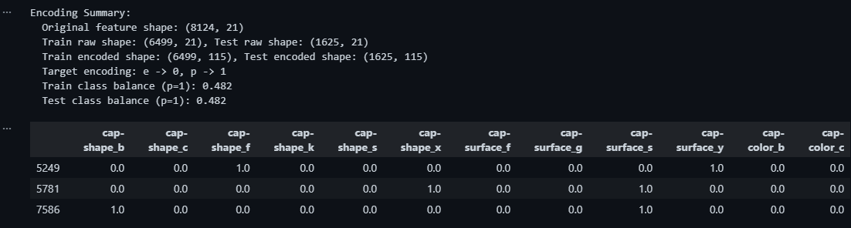
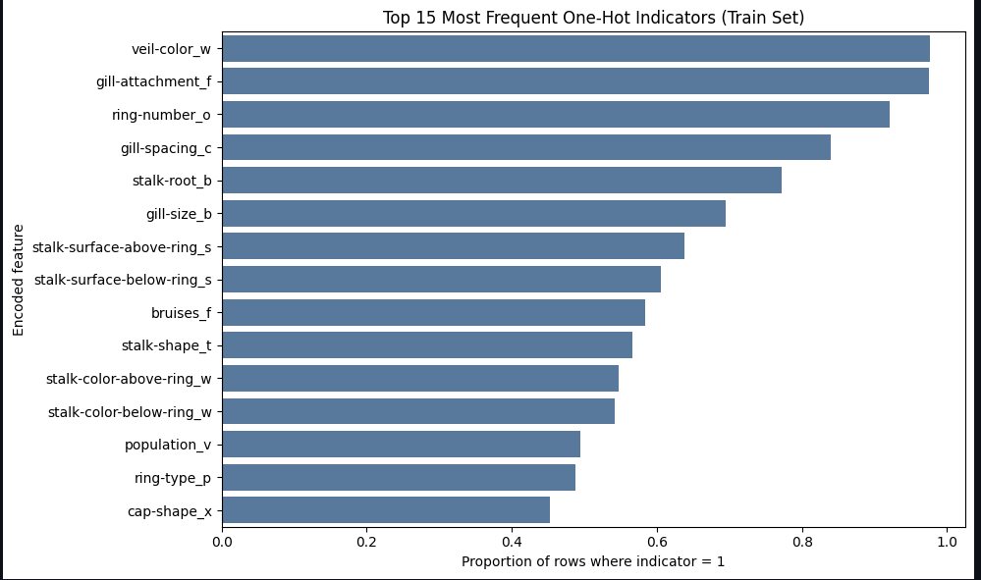

7.0 Conclusion

In conclusion, Phase 1 successfully transformed the mushroom dataset into a clean, analysis-ready foundation for modeling. We handled missing values and duplicates, identified rare categorical outliers using a suitable frequency-based method, and assessed feature relationships with Cramer's V and Theil's U. These steps improved data quality and clarified which variables carry the strongest signal for distinguishing edible from poisonous mushrooms.
The dataset is now properly prepared for Phase 2 through leakage-safe encoding and train-test separation, ensuring reliable model evaluation. Overall, this phase delivered a robust and reproducible preprocessing pipeline, along with clear feature insights that support confident classifier development in the next

